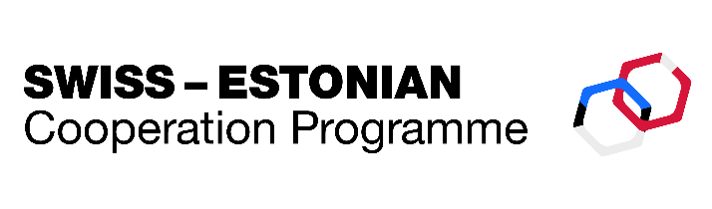

Swiss-Estonian Cooperation Programme

Support Measure "Supporting Social Inclusion"

**Minutes of the written procedure**

**Date:** 08.04.2025 – 10.04.2025

**The decision-making process:**

On 8 April 2025, the Programme Operator submitted to the members of the Steering Committee a proposal to approve changes to the logframe of the Support Measure “Supporting Social Inclusion”. The amended logframe was attached to the email. Steering Committee members were asked to agree or disagree with the proposal by 10 April (inclusive).

The following responses were received from the members of the Steering Committee by the set deadline:

|  |  |  |  |
| --- | --- | --- | --- |
| Members with Voting Rights: | | | |
| Kärt Kallion | Chair, Representative of the Programme Operator, Ministry of Culture | Agree |
| Evelin Liechti | Swiss Contribution Office of the Swiss Embassy to Estonia | Agree |
| Helena Musthallik | Representative of the National Coordination Unit, State Shared Service Centre | Agree |
| Members without Voting Rights: | | | |
| Keit Spiegel | Representative of the Programme Component Operator (Component 1), Ministry of Culture | Agree |
| Ülar Vaadumäe | Representative of the Programme Component Operator (Component 2), Ministry of Social Affairs | Agree |
| Anu Vau | Representative of the Programme Component Operator (Component 3), Ministry of Education an Research | Agree |
| Minna Harjo | Representative of the Programme Component Operator (Component 4), Ministry of the Interior | Agree |

The quorum requirement was met, as the Program Operator, National Coordination Unit and Swiss Contribution Office responded. All members of the Steering Committee agreed to the decision.

Based on the responses received by email **the following decision has been adopted:**

**to approve the changes to the logframe of the support measure “Supporting Social Inclusion” as attached.**

Chair Minutes secretary

(digitally signed) (digitally signed)

Kärt Kallion Olga Gnezdovski

Head of Foreign Financing Coordinator of Estonian-Swiss cooperation programme

Annex 1: Approved logframe with clarifying comments and tracked changes

Annex 2: Clean version of the approved logframe